**Lab 6: NPN Common Emitter Amplifier (3% of total)**

**Objective:**

To become familiar with DC operation of NMOS transistor in two regions: (1) saturation region and (2) triode region.

**Equipment and Components:**

* Breadboard, Power supply, Digital Multimeter
* NMOS transistor (2N7000TA)
* Resistors (3MΩ, 3MΩ, others per design)

**Background:**

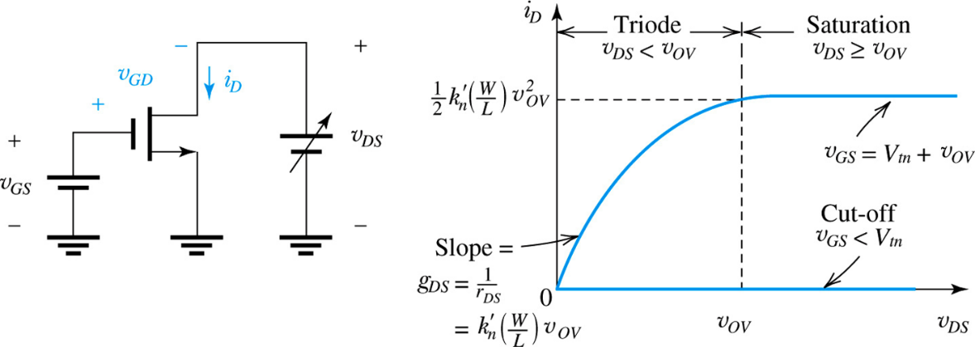

**Fig. 1 NMOS *iD-VDS* characteristics in Triode and Saturation regions: here *vGS* > *Vtn***

Fig. 1 shows how an NMOS operates in two different regions: triode and saturation. Recall that when ***vDS*** < ***vOV***, the NMOS is said to be in triode region and when ***vDS*** > ***vOV*** , it is said to be in saturation region. In triode region, current ***iD*** depends heavily on ***vDS*** whereas in the saturation region, ***iD*** has very little dependence on ***vDS.*** The property of NMOS in saturation region is important for its use as an amplifier.

**Pre-Lab:**

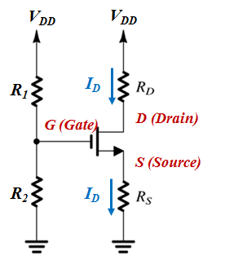

**Fig. 2 NMOS circuit for Triode- and Saturation-mode operation**

* Record your values in the summary table as you go through the following steps.

**Part 1: NMOS in Saturation Mode**

*Design/ Calculate:* (Use Example 5.6 as a guide)

1. Design the circuit in Fig. 2 such that ***ID*** = **1 mA**, ***VD =* 10 V**, and ***VDD =* 15 V**.
2. Assume ***R1*** = ***R2* = 3 MΩ,** and ***kn* = 1.08 mA/V2**. Use **2N700TA** (or 2N7002)as the NMOS transistor.
3. Calculate the overdrive voltage, *VOV*.
4. Determine *VGS*.

***Note:*** Use the datasheet to find the gate threshold voltage.

1. Find *VS*, and use it to calculate *RS* and *RD*

*Simulate:*

1. Using the values found above, simulate the circuit.
2. Record the values of *VS*, *VD, VG*, and *ID*

***Note:*** The simulator has its own, more complex model of the real transistor, so there should be some small variations.

**Part 2: NMOS in Triode Mode**

*Design/ Calculate:*

1. Redesign the circuit for Triode Mode, such that ***ID*** = **1 mA**, ***VD = 6* V**, ***VDS =* 0.26 V**, and ***VDD =* 15 V**.
2. Calculate the overdrive voltage, *VOV*, *VG*, and *VGS*.
3. Calculate *RS* and *RD .*

*Simulate:*

1. Using the values found above, simulate the circuit.

***Note:*** You may need to adjust the values of *RD* and *RS*until you achieve *VD* ~ 6 V. Verify that you are still in the triode region (*VDS < VOV*).

1. Record the values of *VS*, *VD, VG*, and *ID*

**Procedure:**

**Part 1: NMOS in Saturation Mode**

1. On a breadboard, assemble the circuit using values from pre-lab Part 1.
2. Using a digital multimeter, measure *VS*, *VD, VG*.
3. Now, measure all the resistors to three significant digits.

***Note:*** The circuit should not be powered while measuring resistance.

1. Using the measured values of *VS*, *VD,* and the resistors, what is the measured value of *ID* ?

**Part 2: NMOS in Triode Mode**

1. On a breadboard, assemble the circuit using values from pre-lab Part 2. You may need to adjust the values of *RD* and *RS* until you achieve *VD* ~ 6 V.
2. Using a digital multimeter, measure *VS*, *VD, VG*.
3. Now, measure all the resistors to three significant digits.
4. Using the measured values of *VS*, *VD,* and the resistors, what is the measured value of *ID* ?

**Conclusion:**

1. Summarize the calculated, simulated, and measured results in a tabular form, for both Saturation mode and Triode mode. The table should include the following parameters: *R1*, *R2*, *VG*, *VS*, *RS*, *VD, RD, ID, VOV*, *VGS,* and*VDS*. Explain any discrepancies.

*Get your summary table checked off by the instructor.*